#Q1

create table CLIENT_MASTER(

CLIENTNO VARCHAR2(6),

NAME VARCHAR2(20) NOT NULL,

CITY VARCHAR2(15),

PINCODE NUMBER(8),

STATE VARCHAR2(15),

BALDUE NUMBER(10,2),

PRIMARY KEY(CLIENTNO),

CONSTRAINT CHK_C CHECK(CLIENTNO LIKE 'C%')

);

create table PRODUCT_MASTER(

PRODUCTNO VARCHAR2(6),

DESCRIPTION VARCHAR2(15) NOT NULL,

PROFITPERCENT NUMBER(4,2) NOT NULL,

UNITMEASURE VARCHAR2(10) NOT NULL,

QTYONHAND NUMBER(8) NOT NULL,

REORDERLVL NUMBER(8) NOT NULL,

SELLPRICE NUMBER(8,2) NOT NULL CHECK (SELLPRICE<>0),

COSTPRICE NUMBER(8,2) NOT NULL CHECK (COSTPRICE<>0),

PRIMARY KEY(PRODUCTNO),

CONSTRAINT CHK_P CHECK(PRODUCTNO LIKE 'P%')

);

create table SALESMAN_MASTER(

SALESMANNO VARCHAR2(6),

SALESMANNAME VARCHAR2(20) NOT NULL,

ADDRESS1 VARCHAR2(30) NOT NULL,

ADDRESS2 VARCHAR2(30),

CITY VARCHAR2(20),

PINCODE NUMBER(8),

STATE VARCHAR2(20),

SALAMT NUMBER(8,2) NOT NULL CHECK(SALAMT<>0),

TGTTOGET NUMBER(6,2) NOT NULL CHECK (TGTTOGET<>0),

YTDSALES NUMBER(6,2) NOT NULL,

REMARKS VARCHAR2(60),

PRIMARY KEY(SALESMANNO),

CONSTRAINT CHK_S CHECK(SALESMANNO LIKE 'S%')

);

create table SALES_ORDER(

ORDERNO VARCHAR2(6) CHECK(ORDERNO LIKE 'O%'),

CLIENTNO VARCHAR2(6),

ORDERDATE DATE NOT NULL,

DELYADDR VARCHAR2(25),

SALESMANNO VARCHAR2(6),

DELYTYPE CHAR(1),

BILLYN CHAR(1),

DELYDATE DATE,

ORDERSTATUS VARCHAR2(10),

PRIMARY KEY(ORDERNO),

FOREIGN KEY(CLIENTNO) REFERENCES CLIENT_MASTER(CLIENTNO),

FOREIGN KEY(SALESMANNO) REFERENCES SALESMAN_MASTER(SALESMANNO)

);

create table SALES_ORDER_DETAILS(

ORDERNO VARCHAR2(6),

PRODUCTNO VARCHAR2(6),

QTYORDERED NUMBER(8),

QTYDISP NUMBER(8),

PRODUCTRATE NUMBER(10,2),

FOREIGN KEY(ORDERNO) REFERENCES SALES_ORDER(ORDERNO),

FOREIGN KEY(PRODUCTNO) REFERENCES PRODUCT_MASTER(PRODUCTNO)

);

#Q2

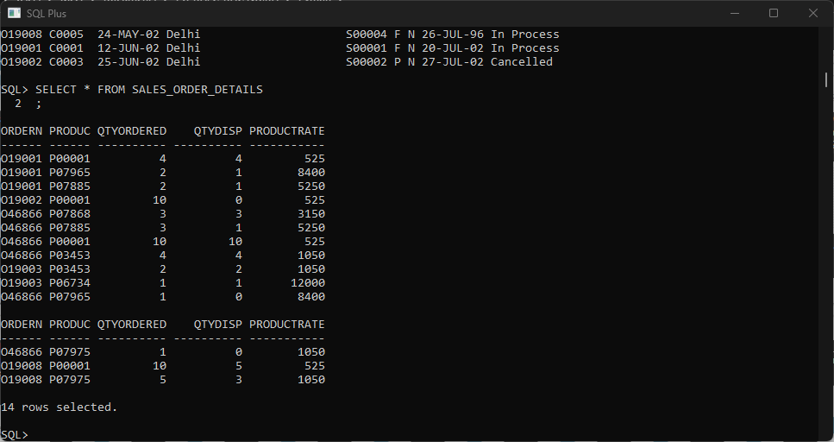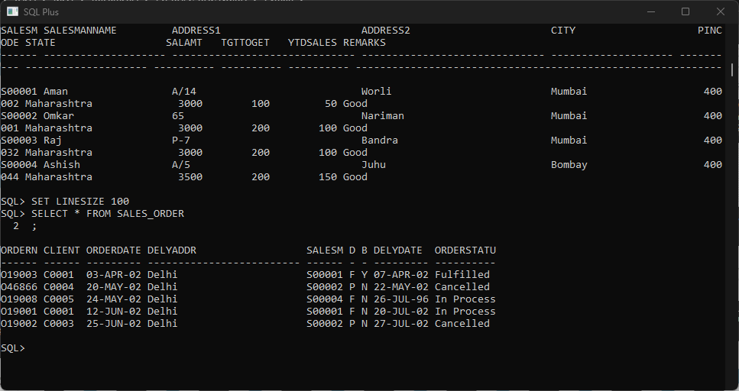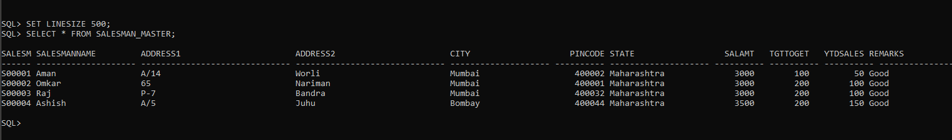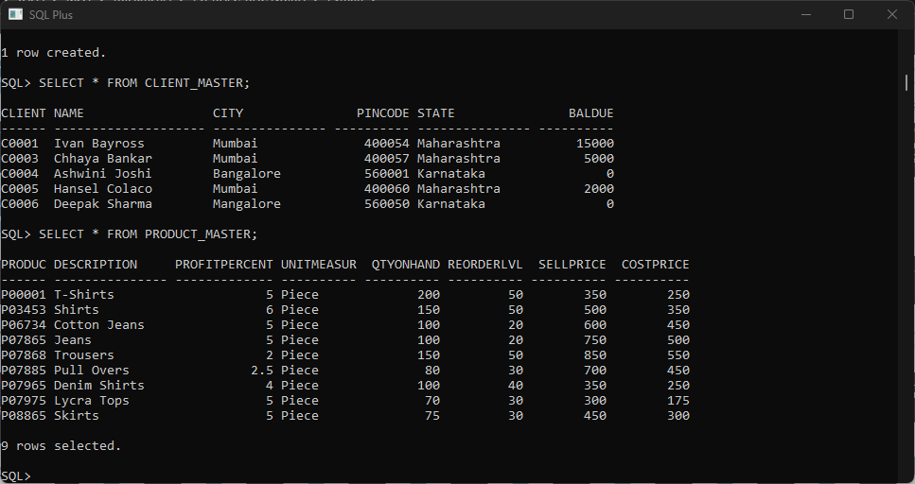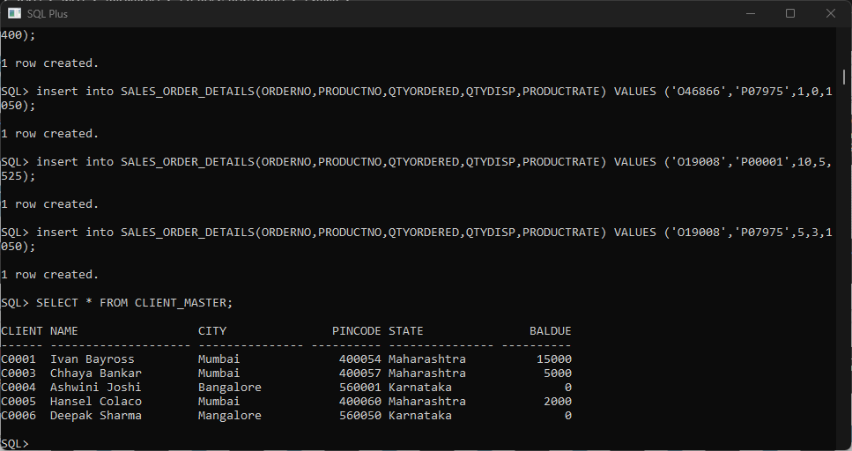

#Q3

1. SELECT NAME FROM CLIENT_MASTER WHERE NAME LIKE '_a%';
2. SELECT NAME FROM CLIENT_MASTER WHERE CITY LIKE 'M%';
3. SELECT NAME FROM CLIENT_MASTER WHERE CITY LIKE 'Bangalore' OR CITY LIKE 'Mangalore';
4. SELECT NAME FROM CLIENT_MASTER WHERE BALDUE>10000;
5. SELECT * FROM SALES_ORDER WHERE ORDERDATE LIKE '%JUN%';
6. SELECT NAME,CITY,STATE FROM CLIENT_MASTER WHERE STATE != 'Maharashtra';

#Q4

a.

from select import select

import cx_Oracle

try:

    con = cx_Oracle.connect('system/Cdac1234@localhost:1521/xe')

except cx_Oracle.DatabaseError as er:

    print('There is an error in the Oracle database:', er)

else:

    try:

        cur = con.cursor()

        cur.execute('SELECT DESCRIPTION, SUM(QTYDISP) FROM PRODUCT_MASTER PM, SALES_ORDER_DETAILS SOD WHERE PM.PRODUCTNO = SOD.PRODUCTNO GROUP BY DESCRIPTION')

        rows = cur.fetchall()

        print(rows)

    except cx_Oracle.DatabaseError as er:

        print('There is an error in the Oracle database:', er)

    except Exception as er:

        print('Error:'+str(er))

    finally:

        if cur:

            cur.close()

finally:

    if con:

        con.close()

b.

from select import select

import cx_Oracle

try:

    con = cx_Oracle.connect('system/Cdac1234@localhost:1521/xe')

except cx_Oracle.DatabaseError as er:

    print('There is an error in the Oracle database:', er)

else:

    try:

        cur = con.cursor()

        cur.execute('SELECT CM.CLIENTNO, AVG(SOD.QTYDISP) AVGSALES FROM SALES_ORDER_DETAILS SOD, CLIENT_MASTER CM, SALES_ORDER SO WHERE CM.CLIENTNO = SO.CLIENTNO AND SO.ORDERNO = SOD.ORDERNO GROUP BY CM.CLIENTNO HAVING MAX(SOD.QTYORDERED * SOD.PRODUCTRATE) > 15000')

        rows = cur.fetchall()

        print(rows)

    except cx_Oracle.DatabaseError as er:

        print('There is an error in the Oracle database:', er)

    except Exception as er:

        print('Error:'+str(er))

    finally:

        if cur:

            cur.close()

finally:

    if con:

        con.close()